**Graphs**

The following graphs describe the structure of the data

1. a **Sample of Dataset**

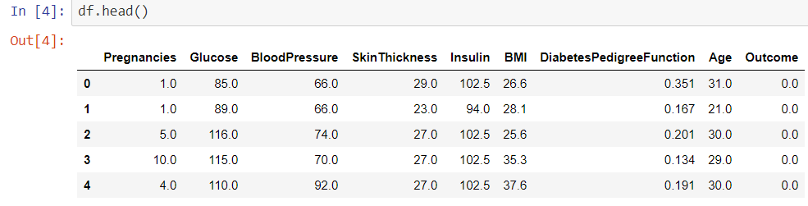

Figure 17: Sample of Dataset

**1. b Correlation Visualization Graph**

This shows the correlation of data

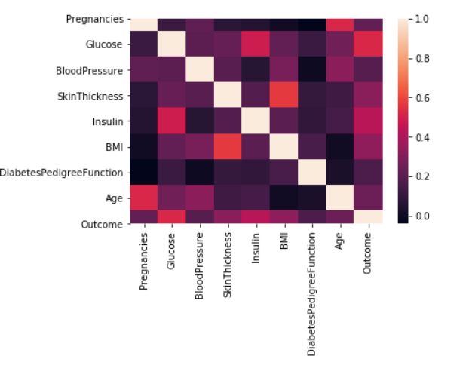

Figure 18 : Correlation visualization graph

1. **Pair Plot**

This shows the distribution of data using the pair plot of the seaborn library.

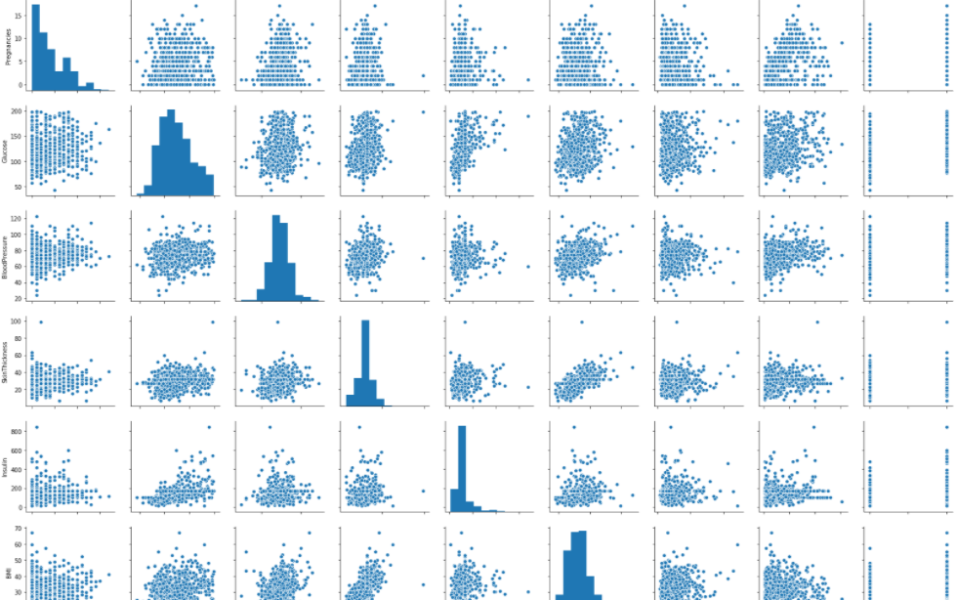 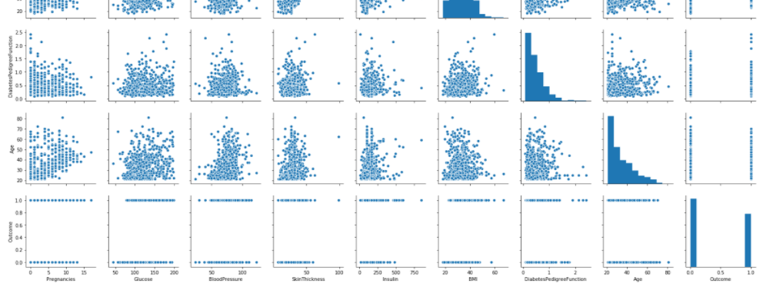

Figure 19 : Pair plot

1. **Count Visualization Graph**

This shows those who are sick or not.

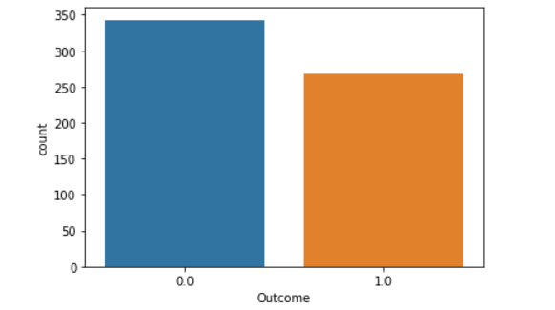

Figure 20 : Count visualization graph

Login form (doctors)

## 

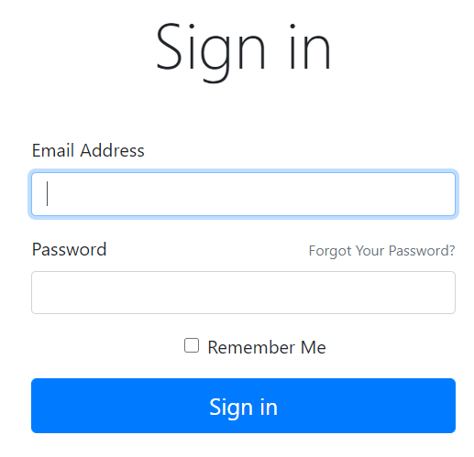

Figure 21: Login form

Registering new doctor to the system

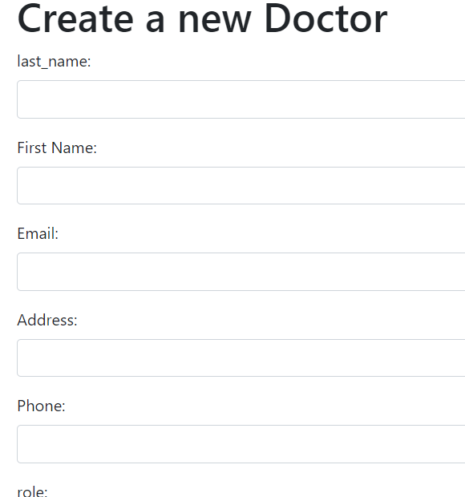

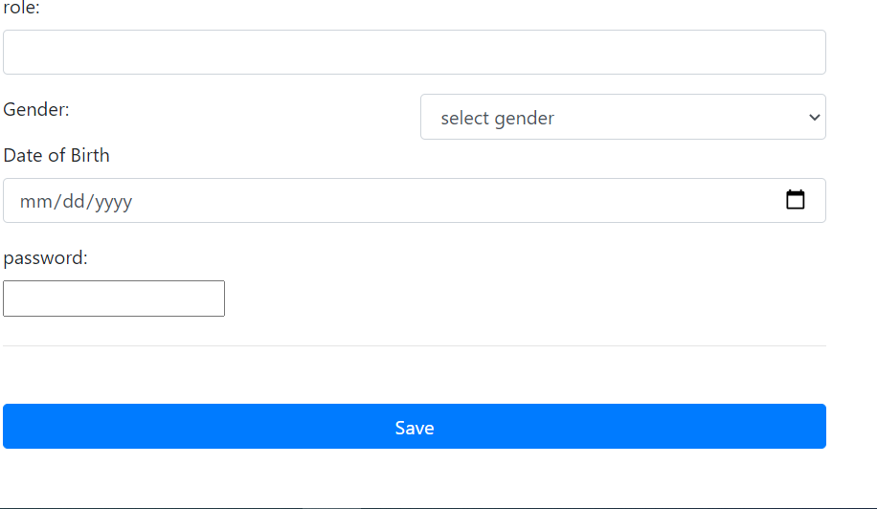

Figure 22 : Registration form of doctor

It is only the admin who is a super user who only create a new doctor. After creating a new doctor, the doctor is eligible to have access to the system at that point the doctor is able of creating a patient and fill his/her examination result and then the system predicts whether the patient is negative or positive.

Registering new patient

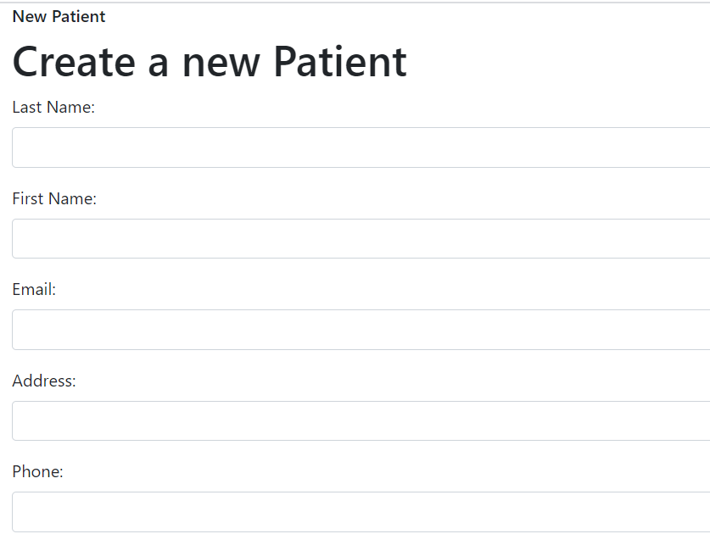 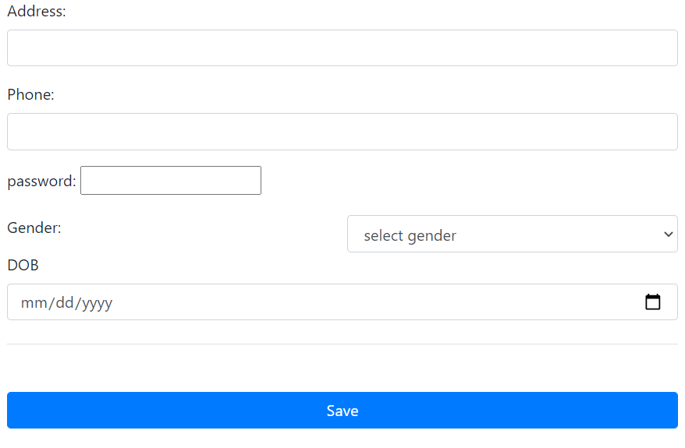

Figure 23 : Patient registration form

### Checking diabetes disease

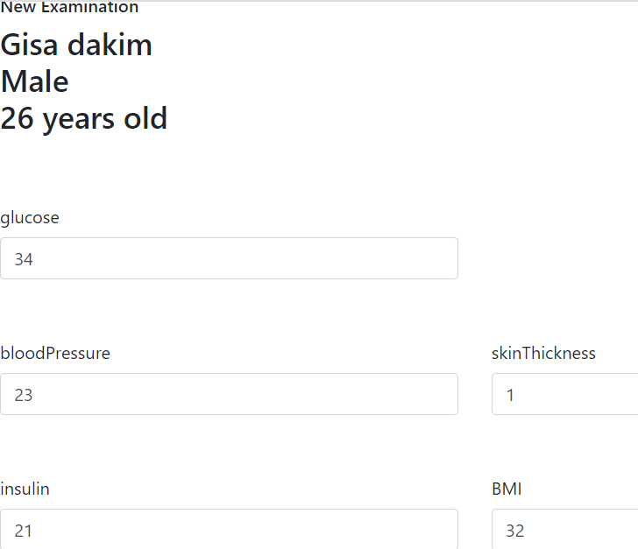 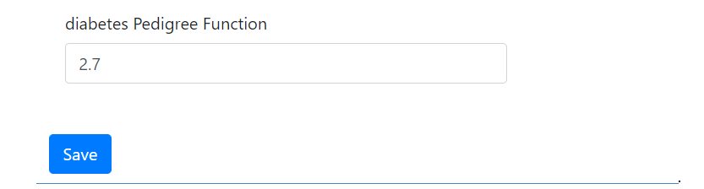

Figure 24 : Checking diabetes

Prediction Result

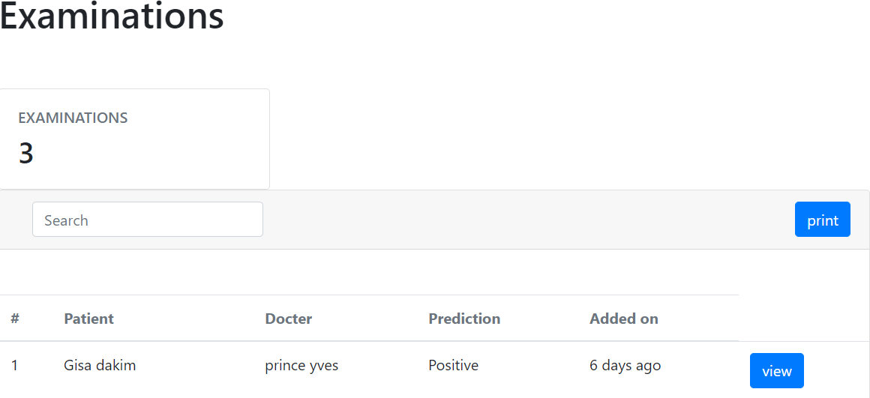

Figure 25 : Prediction result